IMDB Movie Review Sentiment Analysis

Executive Report
Prepared By:
Jose Reyes
MS Business Analytics & Artificial Intelligence
University of Texas Rio Grande Valley
May 2026

Table of Contents
Contents
1. Executive Summary 4
2. Problem Description 4
3. Dataset Description 5
4. Data Preprocessing 5
5. Models Used 6
5.1 Logistic Regression (Baseline Model) 6
5.2 Bidirectional LSTM (Deep Learning Model) 6
5.3 K-Means Clustering (Unsupervised Learning Model) 6
6. Results 7
6.1 Logistic Regression Results 7
6.2 LSTM Results 7
6.3 Clustering Results 8
6.4 Clustering Insights 9
7. Model Comparison 10
8. Real-World Testing 11
9. Conclusion 12
10. Appendix 12

List of Figures

Figure 1: Logistic Regression Confusion Matrix 7
Figure 2: LSTM Confusion Matrix 7
Figure 3: LSTM Training and Validation Performance 8
Figure 4: Review Distribution by Cluster 9
Figure 5: Model Accuracy Comparison 10
Figure 6: Model Predictions on Custom Test Sentences 11
Figure 7: Sample of IMDB Dataset 12
Figure 8: Logistic Regression Classification Report 13
Figure 9: Detailed Model Prediction Comparison 13
Figure 10: LSTM Classification Report 14

1. Executive Summary
This project focuses on sentiment analysis of movie reviews using the IMDB dataset. The objective is to classify reviews as positive or negative using both traditional machine learning and deep learning approaches. Sentiment analysis is widely used in business applications such as customer feedback analysis, brand monitoring, and decision support systems.
The dataset used in this project consists of labeled movie reviews, where each review is categorized as either positive or negative. This provides a supervised learning framework for training classification models. The primary problem addressed in this project is determining whether advanced deep learning models can outperform traditional machine learning methods in sentiment classification tasks.
From an analytic perspective, the problem is framed as a binary classification task in natural language processing. Two modeling approaches were used to address the problem. First, a baseline model using TF-IDF vectorization combined with logistic regression was implemented. Second, a deep learning model using a Bidirectional Long Short-Term Memory (LSTM) network was developed to capture sequential and contextual relationships in the text.
The results showed that the logistic regression model achieved slightly higher accuracy; however, the LSTM model demonstrated strong performance and improved contextual understanding of language. Additional testing using custom sentences further highlighted differences in how each model interprets sentiment. Overall, the project demonstrates that both traditional and deep learning approaches can be effective, and that model selection depends on the specific requirements of the problem.
Additionally, unsupervised learning techniques were applied using clustering to uncover hidden patterns in the data, providing deeper insight beyond sentiment classification.

2. Problem Description
Sentiment analysis is a natural language processing (NLP) technique used to determine whether text expresses positive or negative sentiment. Businesses use sentiment analysis to understand customer opinions, improve services, and support decision-making processes.
In this project, the problem is framed as a binary classification task, where each movie review must be classified as either positive or negative. The goal is to evaluate whether deep learning models can outperform traditional machine learning models in this context.

3. Dataset Description
The dataset used is the IMDB movie review dataset, which contains 50,000 labeled reviews.
- Total records: 50,000
- Classes: Positive, Negative
- Balanced dataset: ~25,000 per class
Each review consists of raw text and a sentiment label. This dataset is widely used for benchmarking sentiment analysis models.

4. Data Preprocessing
Before training models, the text data was cleaned and transformed.
Steps performed:
- Converted all text to lowercase
- Removed HTML tags
- Removed punctuation and special characters
- Removed extra whitespace
Two different preprocessing pipelines were used:
For Logistic Regression:
- TF-IDF vectorization
For LSTM:
- Tokenization
- Sequence conversion
- Padding
These steps ensure that text data can be interpreted by machine learning algorithms.

5. Models Used

5.1 Logistic Regression (Baseline Model)
A logistic regression model was used as a baseline. Text was converted into numerical features using TF-IDF vectorization.
Advantages:
- Simple and fast
- Strong performance on structured text

5.2 Bidirectional LSTM (Deep Learning Model)
A Bidirectional Long Short-Term Memory (LSTM) model was implemented.
Key features:
- Processes text as sequences
- Captures word order and context
- Uses forward and backward information
Enhancements:
- Bidirectional layers
- Dropout for regularization
- Increased sequence length

5.3 K-Means Clustering (Unsupervised Learning Model)
In addition to supervised learning models, an unsupervised learning approach was implemented using K-Means clustering. This method groups similar reviews based on textual patterns without using sentiment labels.
TF-IDF vectorization was used to convert text data into numerical features, which were then used as input for the clustering algorithm. The K-Means model was configured with three clusters to identify natural groupings within the dataset.
This approach allows for the discovery of hidden patterns in the data, providing additional insights beyond binary sentiment classification. Clustering helps identify differences in how users’ express opinions, such as descriptive reviews, negative critiques, and strongly positive feedback.

6. Results

6.1 Logistic Regression Results
- Accuracy: ~89.2%
- Balanced precision and recall
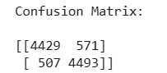
Figure 1: Logistic Regression Confusion Matrix
The confusion matrix shows balanced classification performance for both positive and negative reviews.

6.2 LSTM Results
- Accuracy: ~88.6%
- Strong performance across both classes
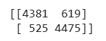
Figure 2: LSTM Confusion Matrix
The LSTM model demonstrates strong performance with balanced predictions across both classes.
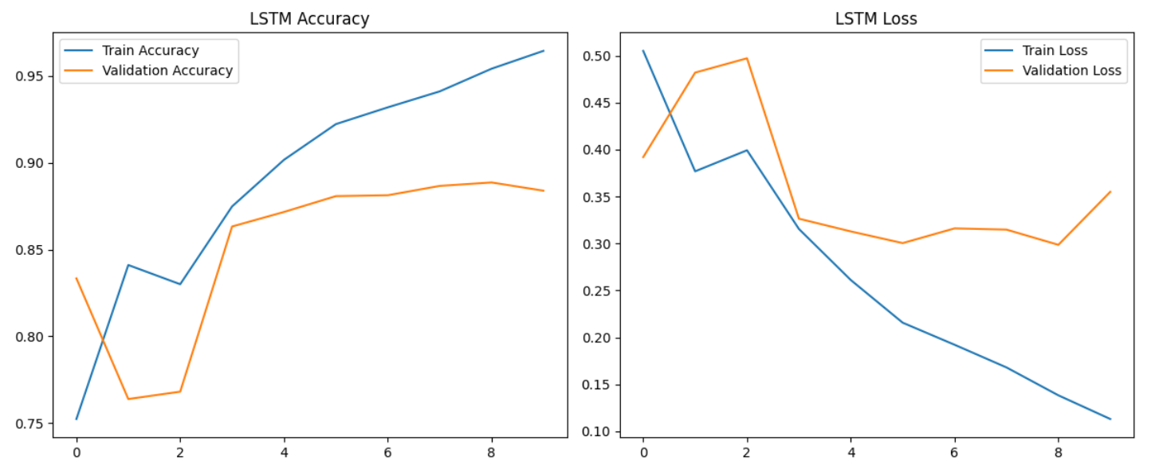
Figure 3: LSTM Training and Validation Performance
The training and validation curves indicate stable learning with minimal overfitting.
Both models achieved strong performance, with logistic regression slightly outperforming the LSTM model. However, the difference in accuracy is minimal, indicating that both approaches are effective for sentiment classification tasks.

6.3 Clustering Results
The K-Means clustering model grouped the dataset into three distinct clusters based on textual features. The distribution of reviews across clusters shows that one cluster contains a larger portion of the dataset, while the other two clusters are smaller but still significant.
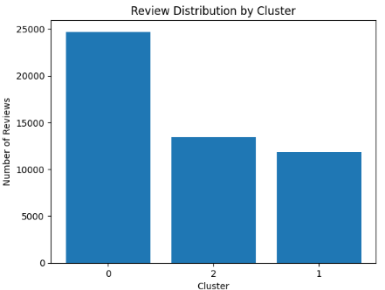
Figure 4: Review Distribution by Cluster
The clustering results reveal meaningful differences in how reviews are structured and expressed. Unlike supervised models, clustering does not rely on sentiment labels, allowing it to identify natural groupings in the data.

6.4 Clustering Insights
The clustering analysis revealed three distinct groups of reviews based on textual patterns.

Cluster 0 appears to focus on narrative and character-driven discussions, with words such as "characters," "story," and "life." These reviews are more descriptive and analytical.

Cluster 1 includes words such as "worst," "bad," "horror," and "acting," indicating negative reviews.

Cluster 2 contains words such as "best," "love," "funny," and "great," reflecting strongly positive reviews.

These findings demonstrate that clustering identifies meaningful patterns beyond sentiment classification, including differences in how users describe movies, express opinions, and emphasize specific aspects such as storyline, acting, or overall quality.

7. Model Comparison
Two models were developed and evaluated for sentiment classification. The logistic regression model using TF-IDF achieved an accuracy of approximately 89.2%, while the Bidirectional LSTM model achieved approximately 88.6%.
Although logistic regression slightly outperformed the LSTM in terms of accuracy, the difference was minimal. The LSTM model demonstrated a stronger ability to capture contextual relationships within text, particularly in cases involving negation and sentence structure.
This comparison highlights that while traditional machine learning models can perform very well on structured text data, deep learning models provide greater flexibility and a deeper understanding of language.
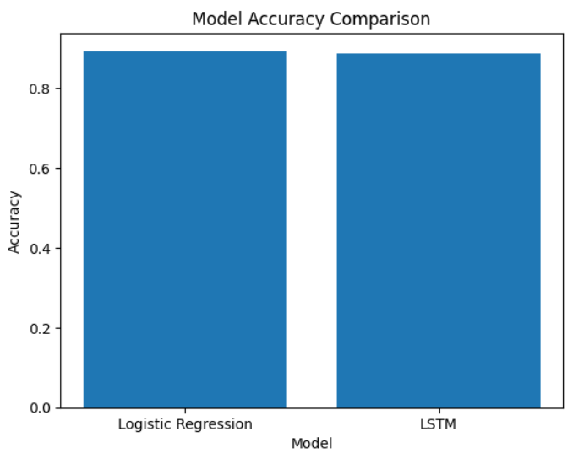
Figure 5: Model Accuracy Comparison
The logistic regression model slightly outperformed the LSTM model in overall accuracy.

8. Real-World Testing
Custom test sentences were used to evaluate model performance outside the dataset.
Examples included:
- “This movie was amazing!”
- “Worst movie ever.”
- “It was okay, not great but not terrible.”

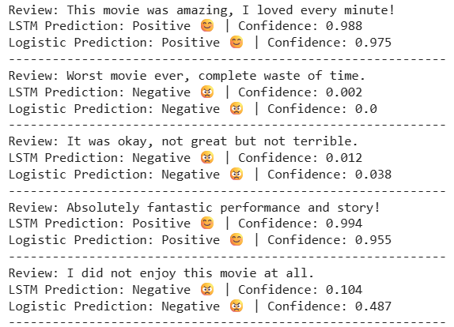
Figure 6: Model Predictions on Custom Test Sentences
Both models performed well on clear sentiment, while LSTM shows stronger confidence in contextual phrases.
Observations:
- Both models performed well on clear sentiment
- LSTM showed stronger confidence in contextual phrases
- Neutral sentences were harder to classify
This demonstrates how models behave in real-world scenarios.

9. Conclusion
This project compared a traditional machine learning model and a deep learning model for sentiment analysis.
Key findings:
- Logistic regression achieved slightly higher accuracy
- LSTM provided better contextual understanding
- Both models performed well overall
The results demonstrate that while simpler models can be highly effective, deep learning models offer advantages in handling complex language patterns.
Additionally, this project incorporated unsupervised learning techniques using K-Means clustering to identify natural groupings of reviews. This provided deeper insight into patterns and themes within the data, demonstrating a more comprehensive analytical approach.
Overall, the combination of traditional machine learning, deep learning, and unsupervised learning techniques highlights the importance of using multiple analytical approaches to fully understand complex text data.

10. Appendix
The appendix contains additional outputs, detailed model results, and supporting visualizations used in the analysis.
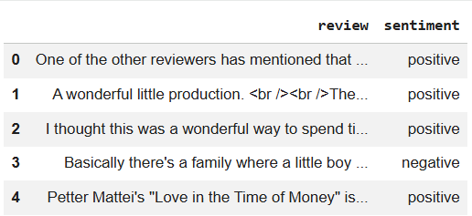
Figure 7: Sample of IMDB Dataset
This figure displays a sample of the IMDB dataset, including raw movie reviews and their corresponding sentiment labels.
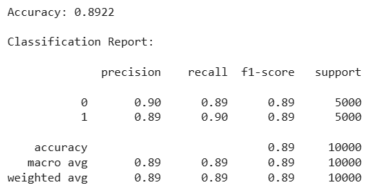
Figure 8: Logistic Regression Classification Report
This classification report summarizes the performance of the logistic regression model, showing precision, recall, and F1-score for both sentiment classes.


Figure 9: Detailed Model Prediction Comparison
This figure presents a detailed comparison of predictions from both the logistic regression and LSTM models, including confidence scores for each custom test sentence.
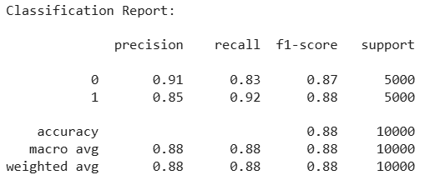
Figure 10: LSTM Classification Report
This classification report summarizes the performance of the LSTM model, highlighting its ability to classify both positive and negative reviews effectively.
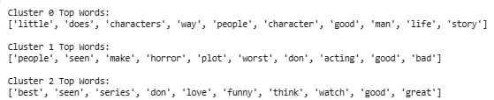
Figure 11: Top Words by Cluster

